Audio Acquisition:
For the simulation purposes, I am getting samples from MATLAB and storing it in coefficient file.
MATLAB Script to get audio data:
% Create an audio recorder object
fs = 44100; % Sampling frequency (44.1 kHz)
bits = 16; % Bit depth
channels = 1; % Mono recording
duration = 1; % Duration in seconds

recObj = audiorecorder(fs, bits, channels);

% Start recording
disp('Start speaking...');
recordblocking(recObj, duration);
disp('Recording stopped.');

% Retrieve audio data
audioData = getaudiodata(recObj);

% Convert audio data to 16-bit unsigned integer with positive values
audioData = uint16((audioData + 1) * (2^15 - 1)); % Normalize and scale to 16-bit range

Audio Data is shifted to fit into 16-bit unsigned data. So, our data is now unsigned integer type.

Vivado Code to manage input data.
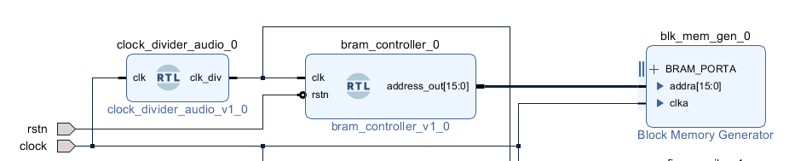

Created clock divider from 100Mhz base clock frequency into 44.1Khz.
Which goes into Bram Controller and it increments the address of the Bram which contains data.
Low Pass Filter and Hamming Window:
Low Pass Filter can be made with hamming window through code for FIR Filter or by using IP. Both are available inside the code. Although IP is preferred which is accurate and configurable.
For FIR Filter, we need to consider tap of the filters and their coefficients.
To get these coefficients we will use “filterDesigner” app in MATLAB.
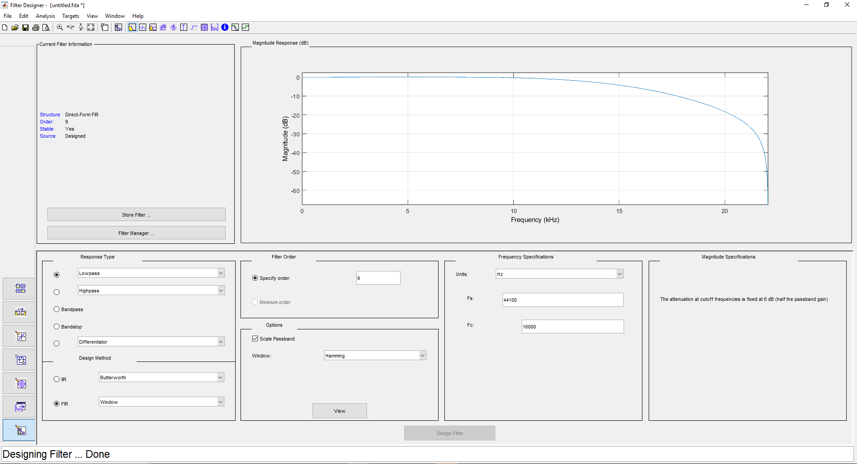

By getting these parameters. We can generate coefficients for the Vivado.
Shift these coefficients by 8 bits and have 8 bits coefficients.
It is passing through 15Khz frequency.
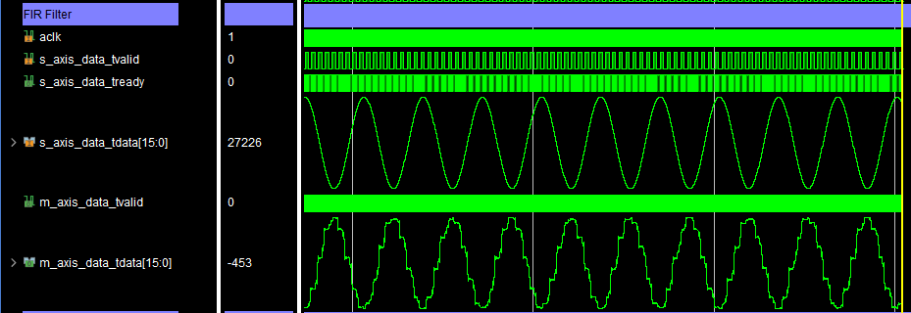

It is not passing through high frequency that good.
Now frequency is 6 Mhz it is not passing high frequency.
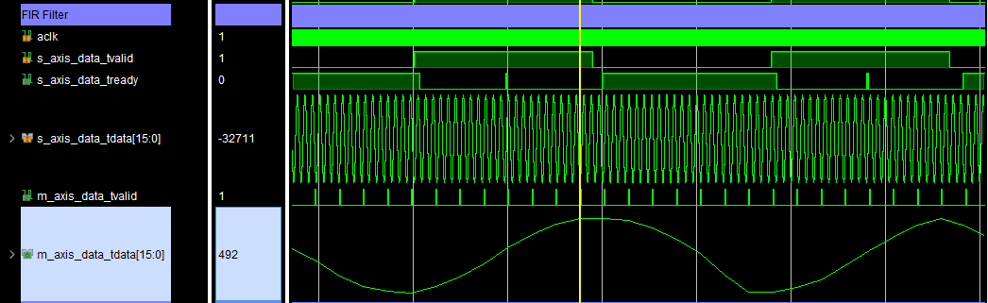

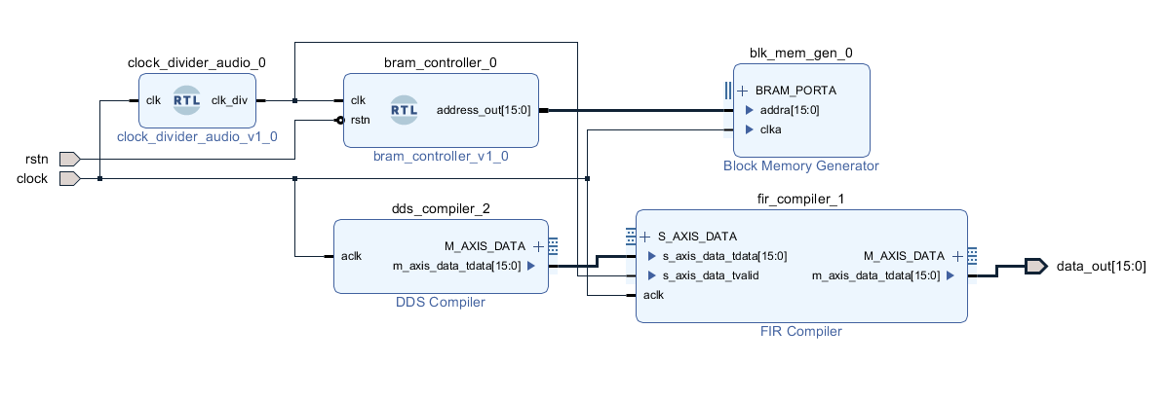
DDS ip is used as tester for the fir low pass filter using hamming window. Filter is 9 tap filter.

